**P6 - Create on-screen help to assist the users of a computer program**

**Introduction**

In this report, I will create an on-screen help to assist the user of a computer program. I will put in screenshots for proof.

**Help and Support**

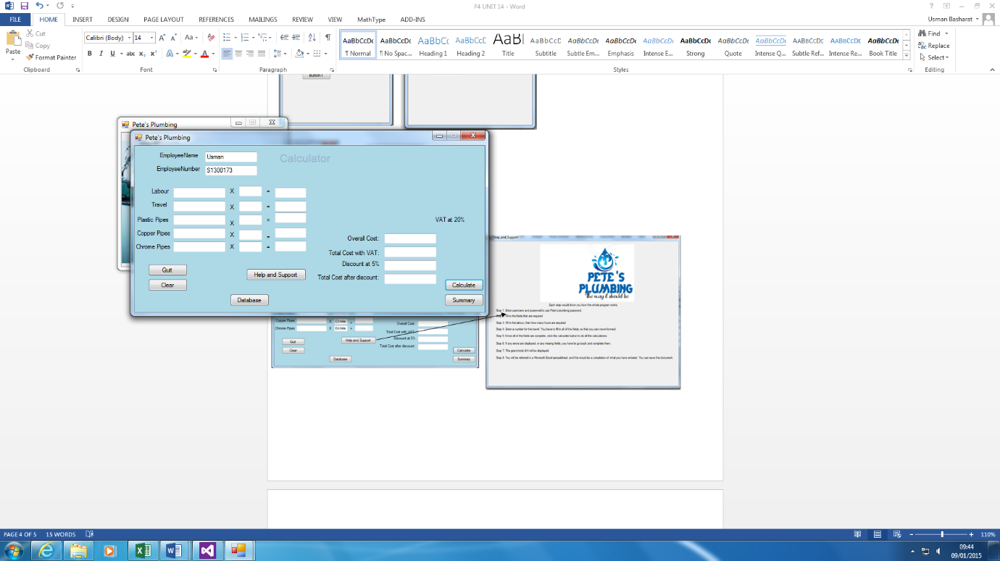

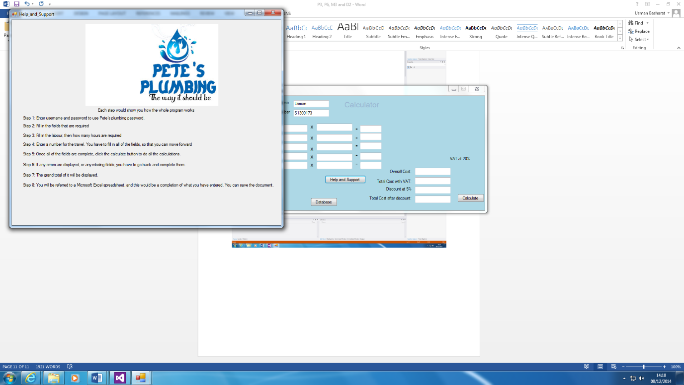

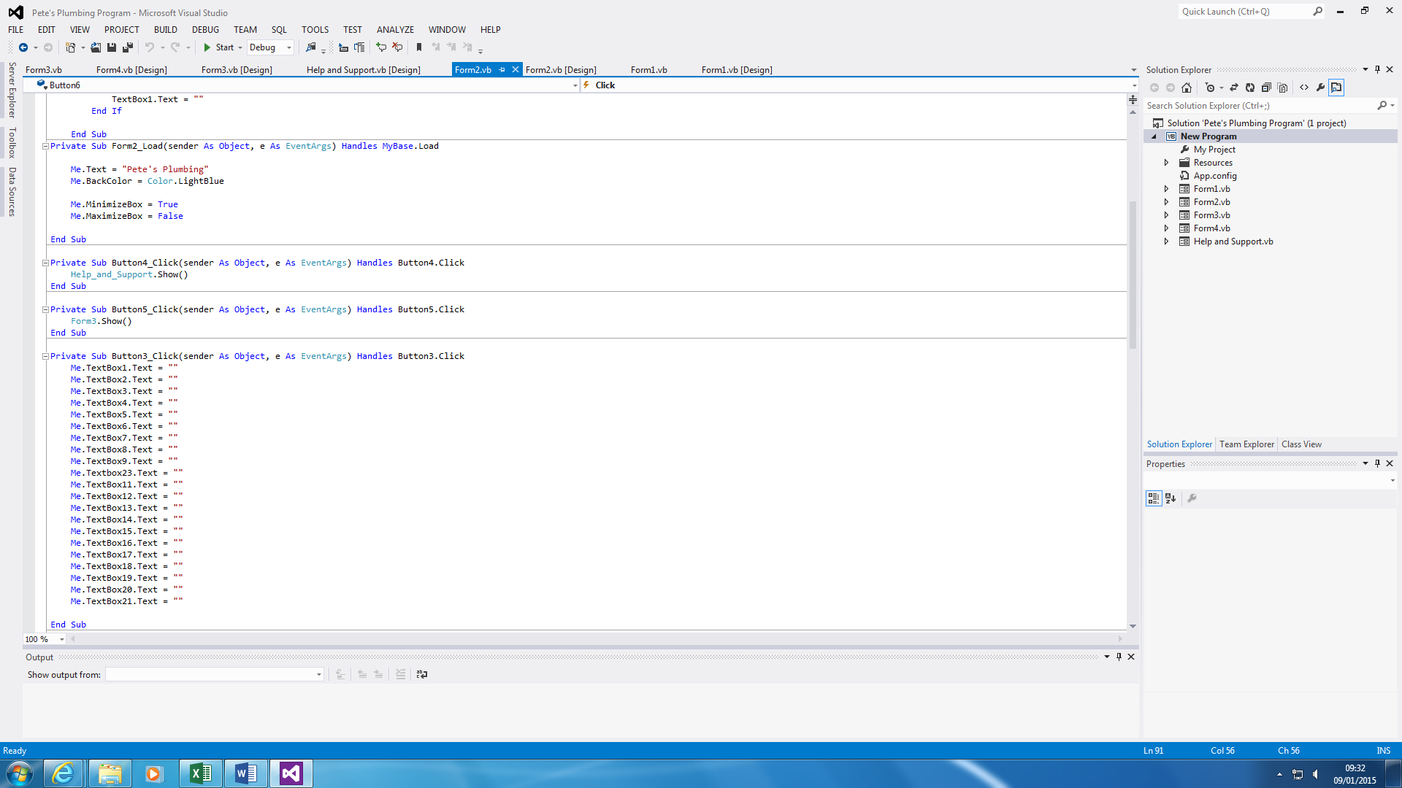

Help and Support button is easy. If the user has any problems with it, he/she can use the systematic guide of how the program is run. As you can see, it shows how it works. For example, if I did not know how to clear the whole Textboxes, I will use the Help and Support button to help me out. All you do is press the button and another sheet shows the steps.

The code is there to show that how Form2 is linked with the Help_and_Support Form. This is what you type to link it together once the button is clicked.